
Symbiosis Institute of Technology, Pune
Faculty of Engineering
CSE- Academic Year 2026-27
Java Programming – Lab Batch 2024-28
Lab Assignment No:- 20
Name of Student: Sanika Botre
PRN No.: 25070122063
Batch: 2025-29
Class: CSE A-2
Academic Year & Semester: 2026 & 3rd Semester
Date of Submission
Title of Assignment: Develop a Java application to establish connectivity with a database and perform INSERT, UPDATE, and DELETE operations.

Learning Objectives: To perform database modification operations using JDBC.

Theory: JDBC allows Java applications to perform database manipulation using SQL Data Manipulation Language (DML) statements such as INSERT, UPDATE, and DELETE. The INSERT statement adds new records into database tables, UPDATE modifies existing records, and DELETE removes unwanted records. These operations are executed using the Statement or Prepared Statement interface. Prepared Statement is generally preferred because it supports parameterized queries, improves performance, and prevents SQL injection attacks. Proper transaction management ensures that database modifications are performed safely and consistently. These operations form the basis of almost every database-driven application such as banking systems, hospital management systems, and student information systems.
Practice questions
1. Create a Java application to manage employee records using CRUD operations.
Code:
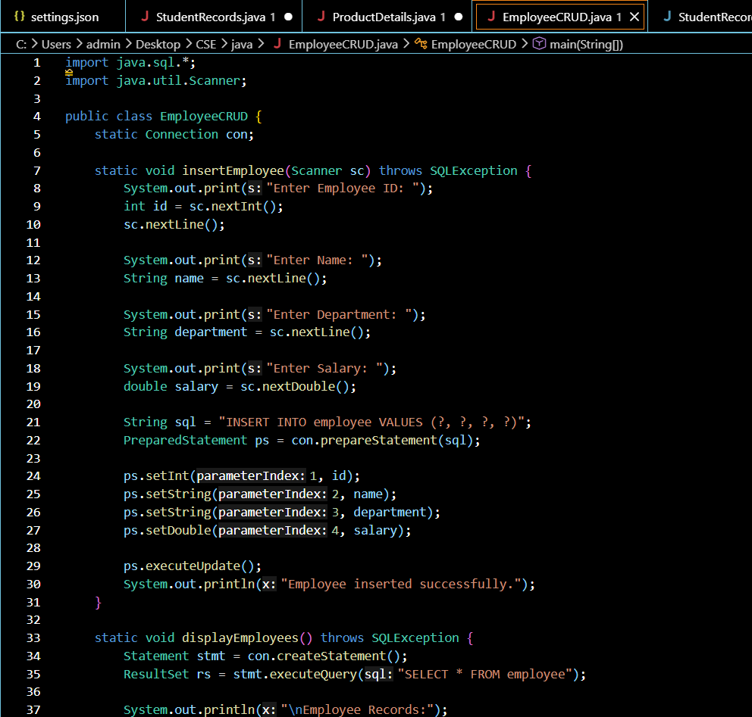
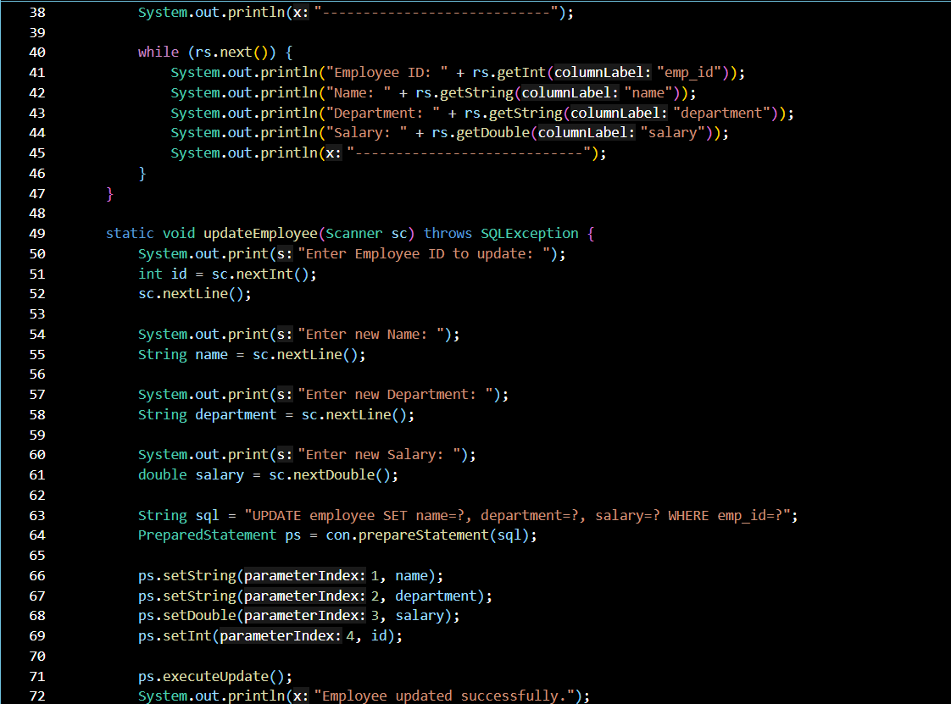
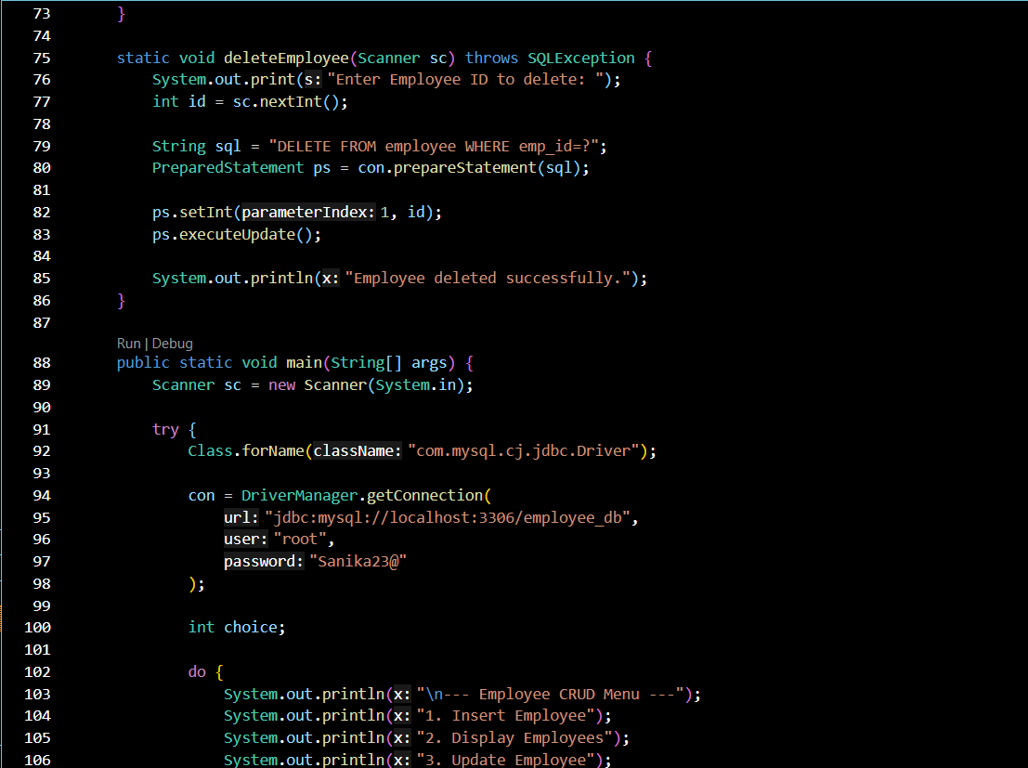
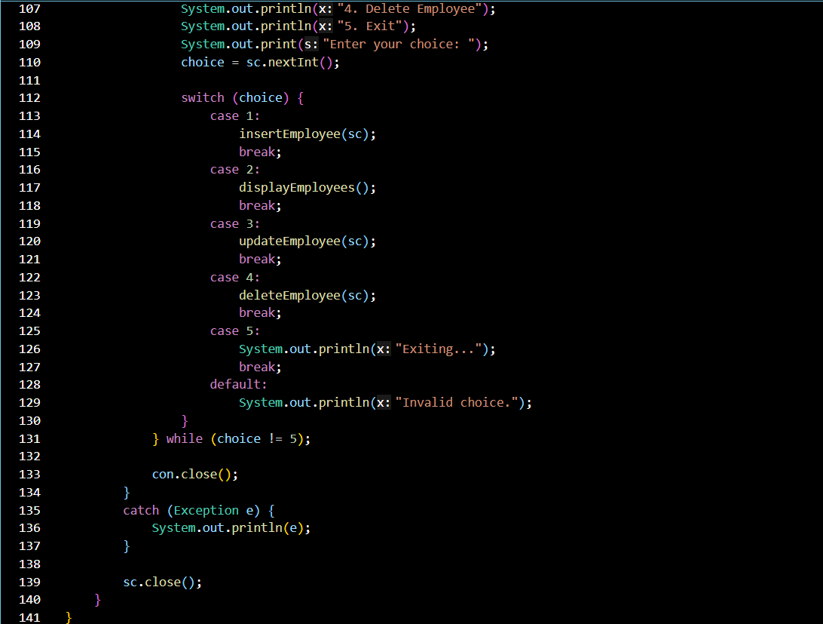

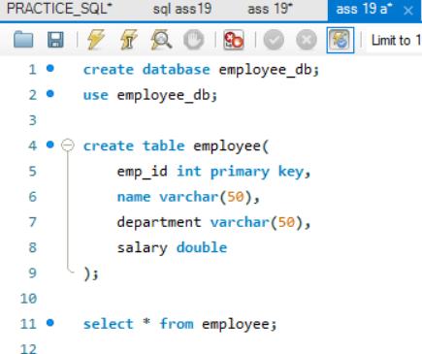

Output:
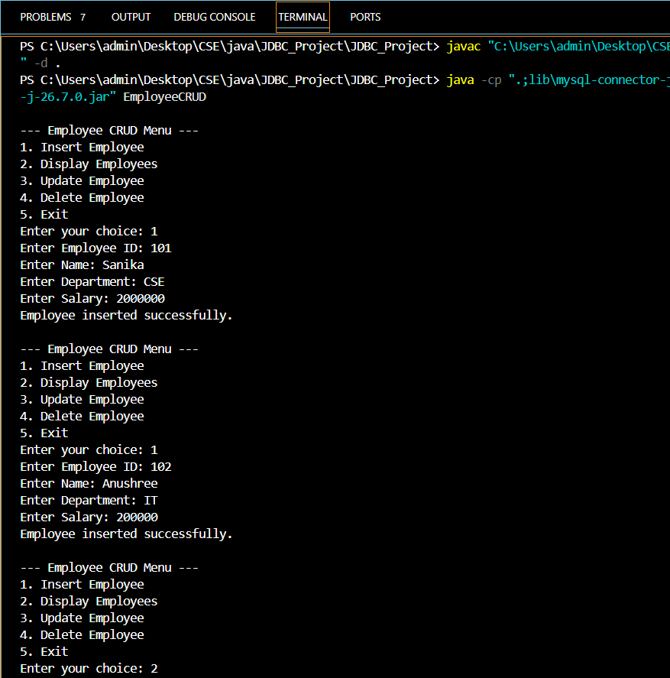
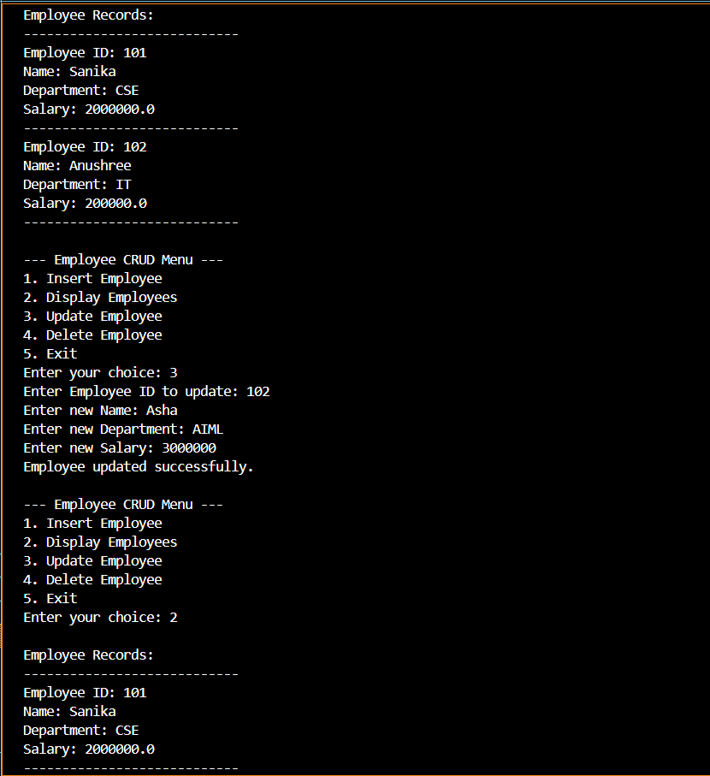
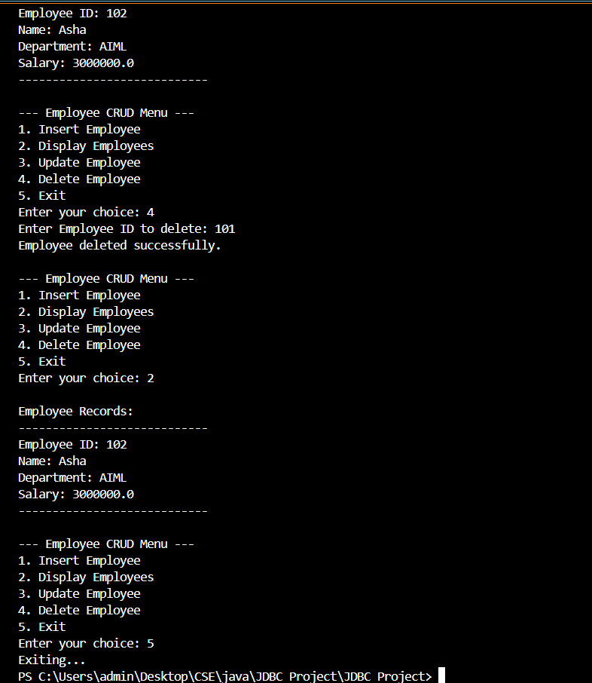

2. Create a Java application to manage student records using CRUD operations. Perform Create, Read, Update, and Delete operations on student details such as roll number, name, course, and marks using a database.

Code:
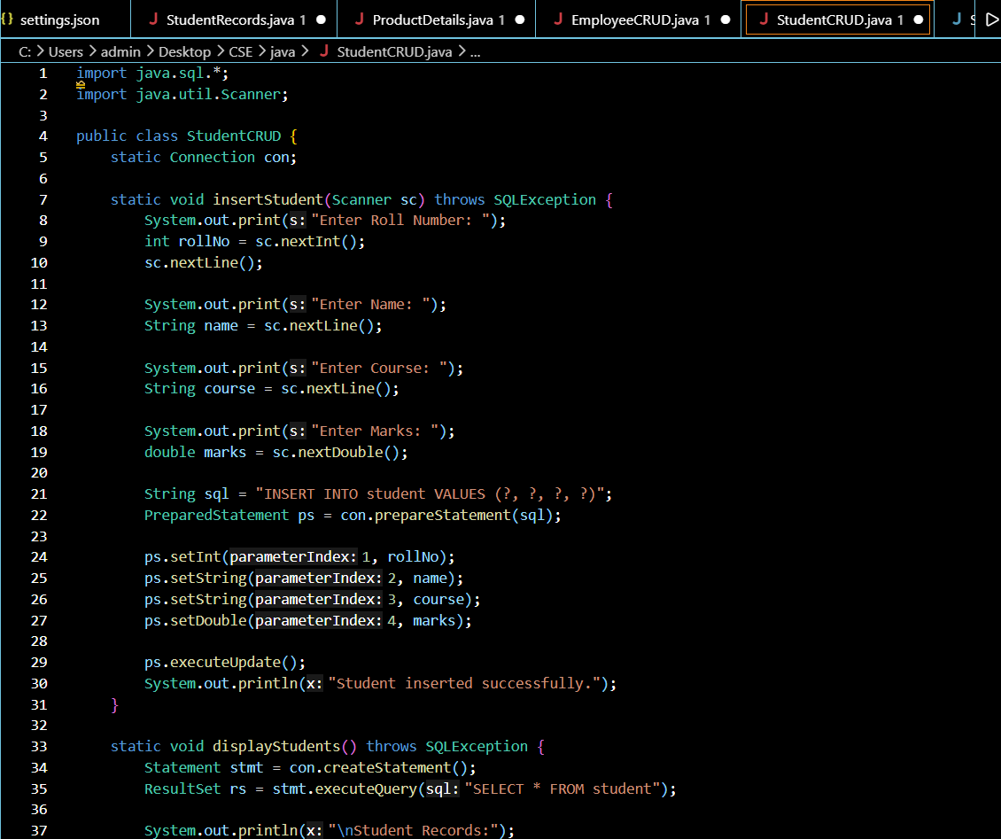
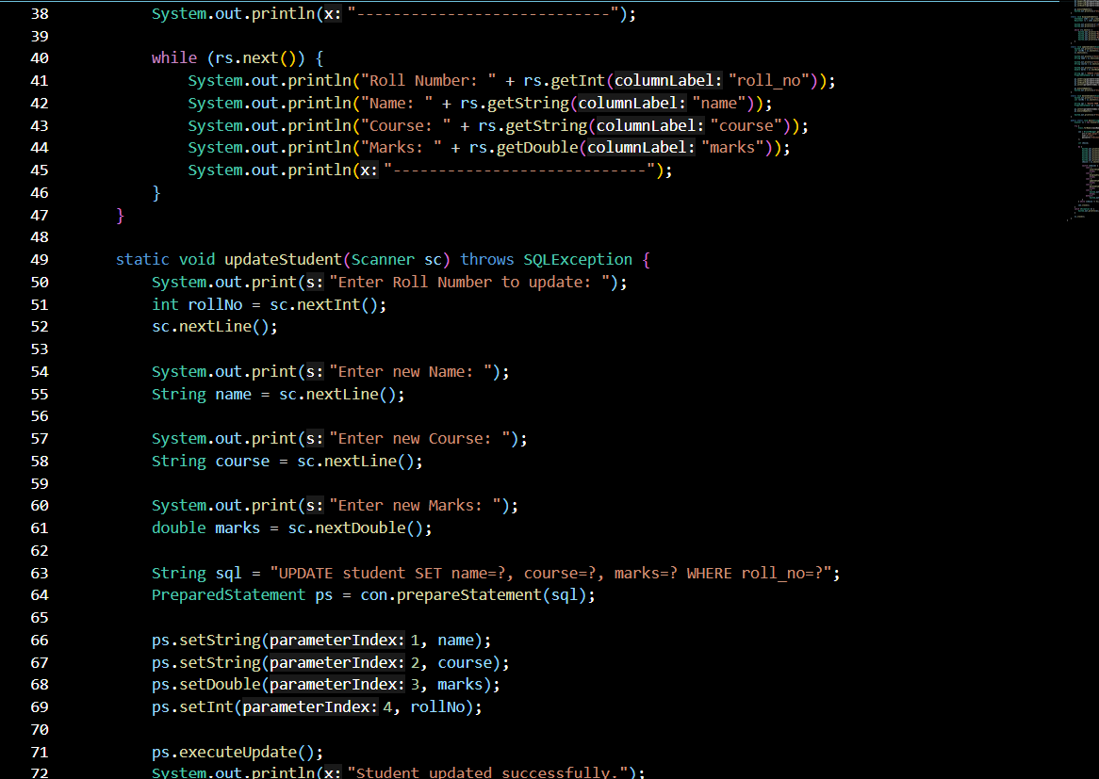
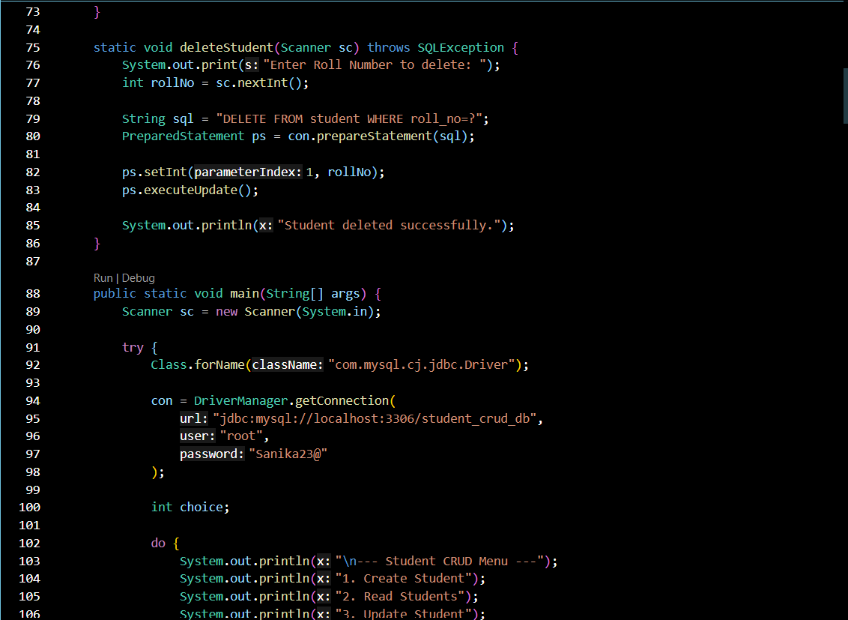
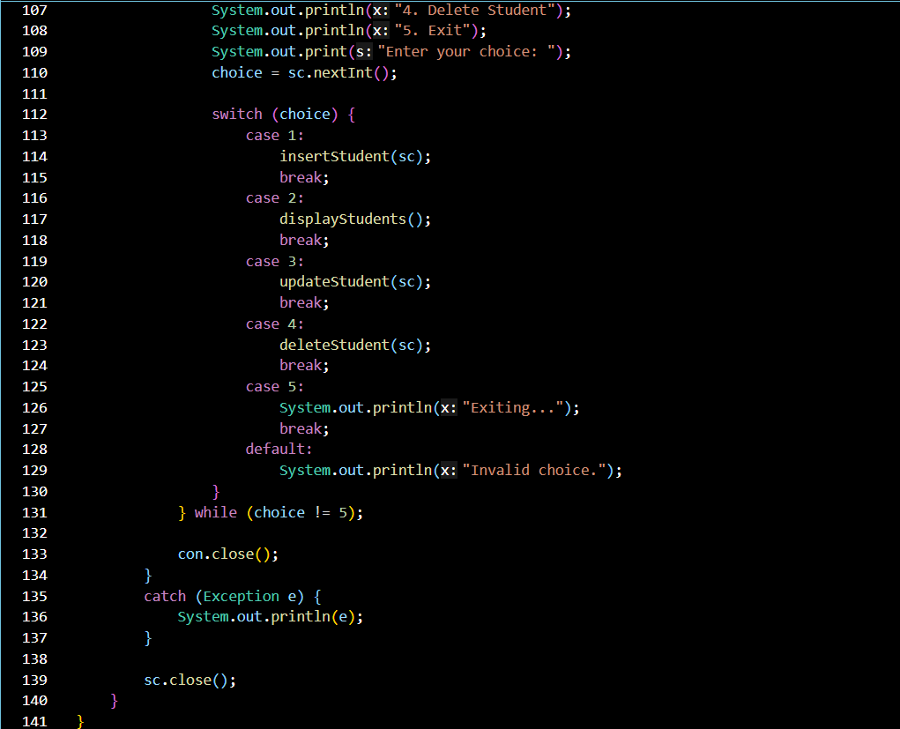
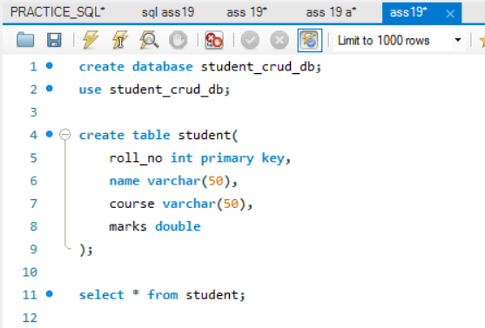

Output:
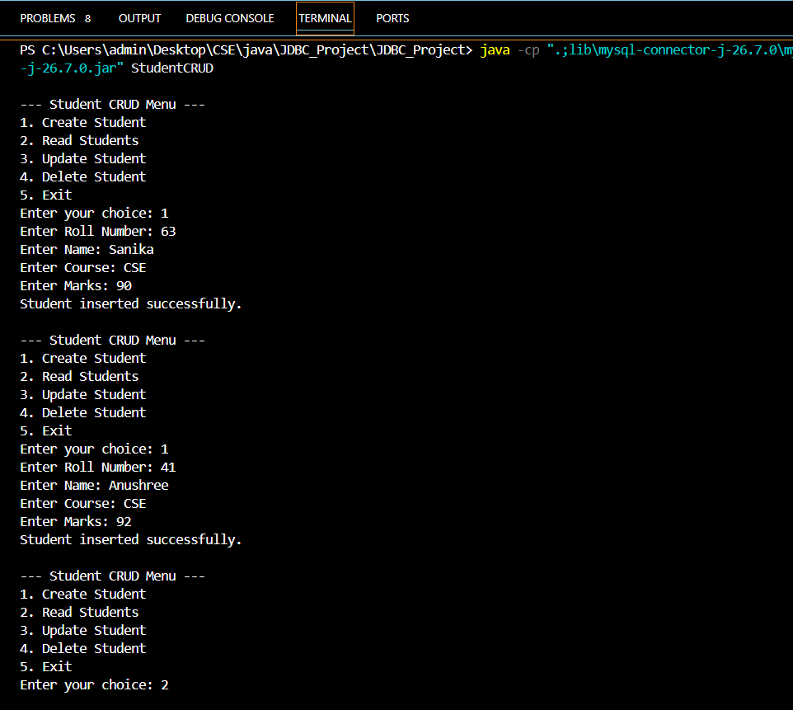
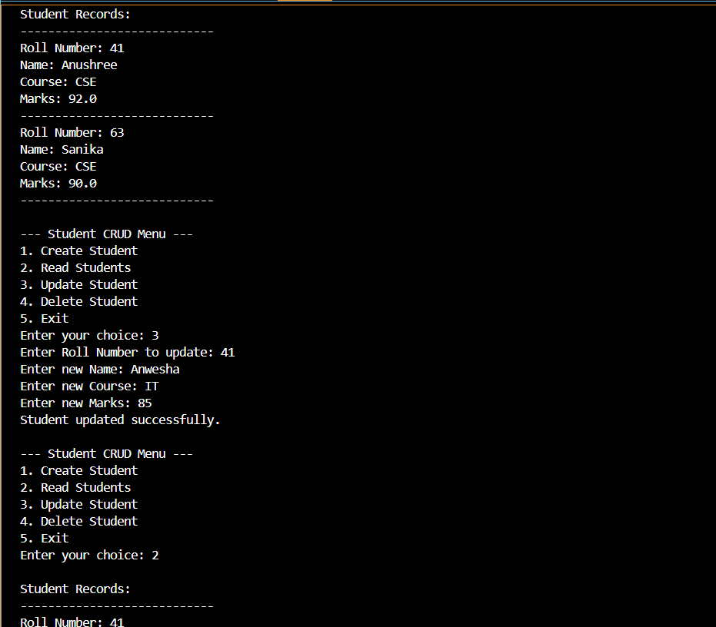
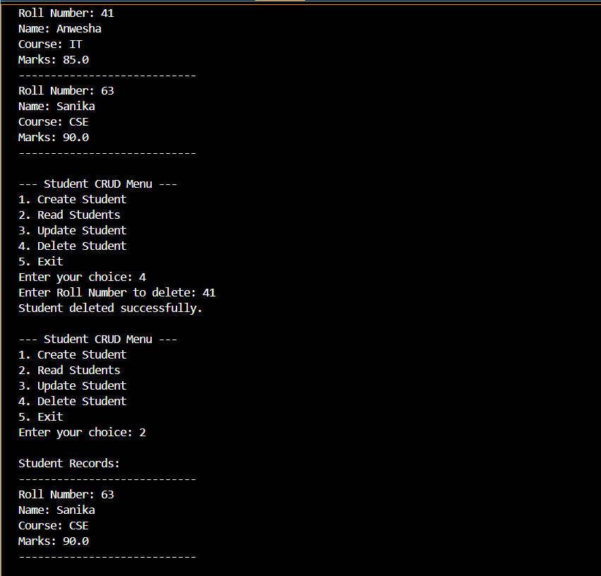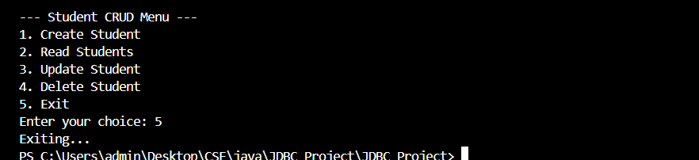

Conclusion
Thus, the Employee Record Management and Student Record Management applications were successfully implemented using JDBC and CRUD operations. The programs allow the user to create, read, update, and delete records stored in a database. The applications demonstrate the use of JDBC connectivity, SQL queries, PreparedStatement, Statement, and ResultSet for managing database records. This assignment provides practical understanding of how Java applications interact with databases to perform CRUD operations.

